Shielded Cables and Their Significance in Industry

Shielded Cables, as the name implies, offer shielding (protection) of some form. But protection from whom?

For this let’s first understand what are electrical cables? Electrical cables are used for transfer of electrical power (current signals) from one machine to the other. Cables are used extensively in electrical devices for power and signal circuits.

Industries like power generation & distribution, chemical & fertilizer industries and various other types of engineering industries – they use a large number of machines/motors – Power Cables supply the electric power to operate these machines and also the factory lights, AC, power to computers, etc. And within these industries, the process instrumentation plays a vital role in measurement, supervision and control of the manufacturing processes. Very low level electrical current signals pass between measuring end and display units/controllers which are situated far off. But these low level signals are prone to external noise pickups during transmission.

Now factory environments are electrically noisy environments. Electrical noise, also called electromagnetic interference (EMI), can disrupt the electrical signals thereby hampering correct operation of the machines/processes. This is despite the cables being PVC insulated. Actually, insulation protects a cable conductor mechanically from abrasions and handling wear & tear and environmentally from humidity and corrosivity. But insulation has no resistance to electromagnetic energy/EMI. That’s where the protection of Shielding is required to combat interference of EMI.
How it’s done – the shield which can be in form of a thin layer of Aluminium Foil or Aluminium/Copper Braiding, which is encapsulated over the cable conductors as an additional layer. This shielding reflects the EMI and also grounds this interference (noise). Only a very low level of residual EMI passes through the shield, but its signal level is too weak to cause any distress.

As explained, there are 2 main types of shielding – Aluminium Foil and Aluminium/Copper Braid.

Foil shielding uses a skinny layer of aluminum, typically attached to a polyester film to
add strength and strings of drain wire. It provides 100% coverage of the conductors it surrounds, which is good. The drain wire is used to ground the shield.
A braid can be a woven mesh of bare or tinned copper or aluminium wires. The braid provides a low-resistance path to ground and is far easier to termination by crimping or soldering when attaching a connector. Since copper has higher conductivity than aluminum; hence the copper braid has more bulk for conducting noise, the braid is more effective as a shield. But it adds size and price to the cable.
For very noisy environments, multiple shielding layers are often used including using
both a foil and a braid. In multi-conductor cables, individual pairs are sometimes shielded with
foil to supply crosstalk protection between the pairs, while the general cable is shielded with
foil, braid, or both.

Pictures of Unshielded & Shielded Cables

Unshielded Flexible Power Cable | 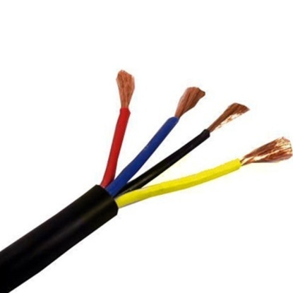
Aluminium Foil with Polyester & Drain Wire Shielded Flexible Cable | 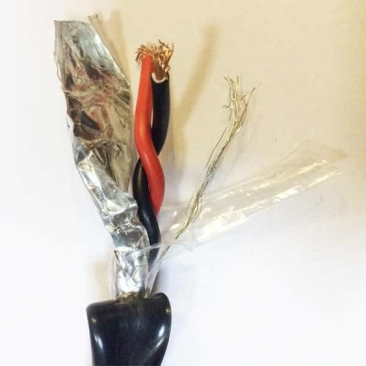
Braided Shielded Cable | 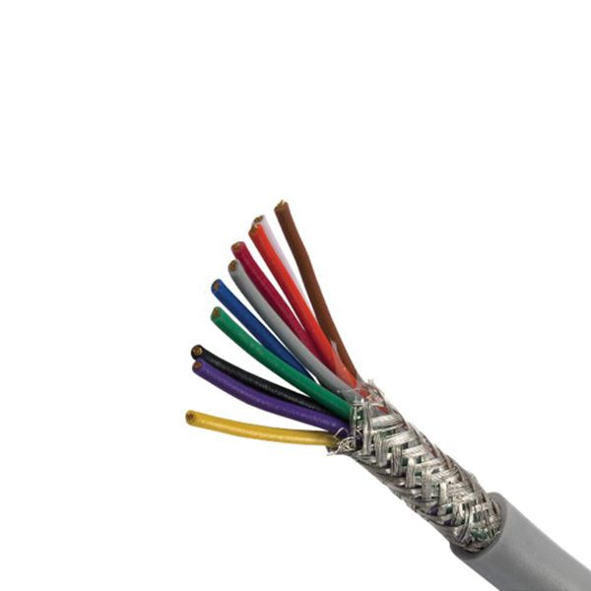
Braided as well as Foil based Shield Cable | 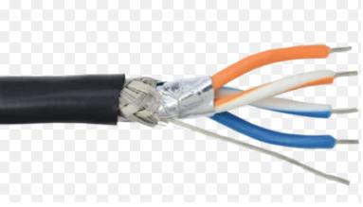

General Guidelines for Cable Shielding

A good brand cable (Finolex, KEI, Polycab, Skytone, etc.) with adequate shielding, for e.g. in moderately noisy environments, a foil shield may provide adequate protection. In noisier environments, consider braided cables or foil-braid combinations.

Ensure that all electrical devices and cables are properly earthed. Use an earth ground wherever possible. Eliminating noise depends on a low resistance path to ground. Ensure all connectors, thimbles & glands allow full 360° termination of the shield. Also Ground the cable at one end.

SOURCE OF EMI NOISE | NOISE LEVEL | TYPICAL LOCATION
Heavy Motors, Generators, Transformers, Induction Heating, Electrolytic Processes | HIGH | Large Factories, Power Plants, Car Factories, Steel Mills, Cement Factories, Refineries
Medium Motors, Control Relays, HVAC systems | MEDIUM | Medium Manufacturing Plants, Neighborhood Industries
Motors < 4kW (5HP), Arcs, Control Relays | LOW | Offices, Godowns, Welding Shops, Small home shop industries

Compiled by: Web Team, Indersons. www.indersonsindia.com
To buy all types of shield and braid cables, visit – www.bestofelectricals.com

